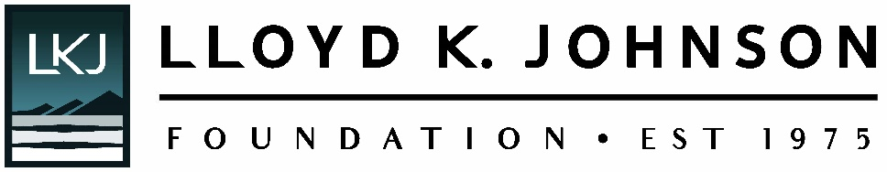

Long-Form Grant Proposal Checklist

What You’ll Need: The following is a checklist of questions you will be asked to respond to as well as documents you will be requested to upload within the online application system.

Organizational Information

- Primary Contact Info (director/leadership)
- Contact Info for Application (if different than above)
- Organization History, Mission, and Goals
- Description of Current Programs, Activities, Strengths, and Accomplishments
- Relationship with other organizations working with similar missions
- Number of Staff, Board Members, and Volunteers
- Date your organization was established, Fiscal Year Start/End Dates

Proposal Information

Request Information:

Organizational budget & Program/Project Budget (if applicable)

Request Amount & Project Title

2-3 Sentence Summary of Request

Project Start & End Date

Program Area: Education, Social Welfare, Arts & Culture, Environment, Comm/Economic Devel.

Geographical Area Served, Population, Age Group, & Total Number Served

Funds requested for: Project, Program, Capital, General Operating, or Start-Up Support

Opportunities, Challenges, Issues, Need, & Community Proposal Addresses

Purpose of Grant:

Overall goal of project, program, or organization (if operating support request)

How was your focus determined?

Who was involved in that decision-making?

Specific Activities & Who will carry out activities

Benefits to the Community & Impact Expected

Long-term Funding Strategies for sustaining this effort (if applicable)

Evaluation

Criteria for Success: Desired Results (immediate and long-term)

How will success be measured and who will evaluate outcomes?

What will you do with your evaluation results?

Attachments:

Program / Project Budget (if applicable)

Organizational Budget

Current Balance Sheet & Income Statement

List of Organizational Funders or Project Funders

Most Recent Audited Financial Statement or IRS Form 990

